
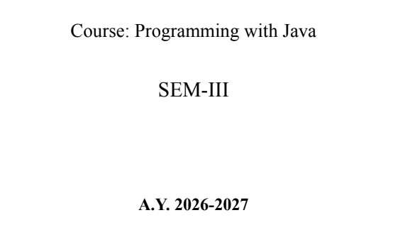
NAME: BHOOMI VIJAYVARGIYA
BATCH: A2
PRN: 25070122062
ASSIGNMENT-10
TITLE :Write a Java program to demonstrate the use of abstract classes and abstract methods
Problem Statement Write a Java program to demonstrate the use of abstract classes and abstract methods
Learning Objectives
To implement abstraction using abstract classes and abstract methods.
Theory
Abstract classes provide partial implementation of a program and cannot be instantiated directly. They may contain both abstract and concrete methods. Abstract methods declare functionality that must be implemented by subclasses. Abstraction hides implementation details while exposing only essential functionality. This improves code flexibility and maintainability in object-oriented programming.
Code:
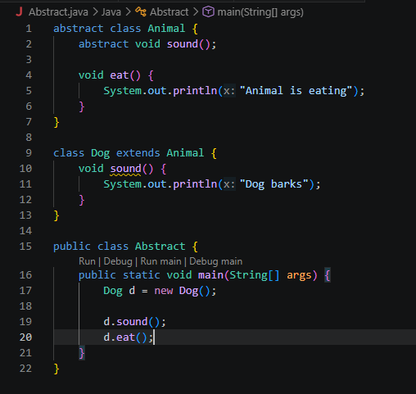
OUTPUT:
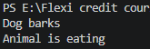
Outcome
• Understood the concept of abstract classes and abstract methods in Java.
• Learned how subclasses provide implementations for abstract methods.
• Successfully implemented and executed the program to achieve the expected output.
Conclusion
The program was implemented and executed successfully. It demonstrated the use of abstraction in Java by defining an abstract class and implementing its abstract methods in subclasses. This approach improves code reusability, flexibility, and supports the object-oriented programming paradigm.
Exercise
- Create an abstract Payment class and implement Credit Card and UPI payment classes.?

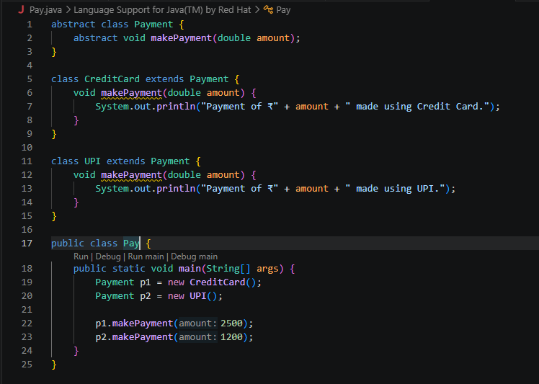
output
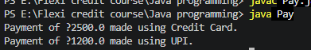
- Create an abstract FoodOrder class with an abstract method calculateBill(). Implement two subclasses, DineInOrder and TakeAwayOrder, to calculate and display the total bill based on the order type.

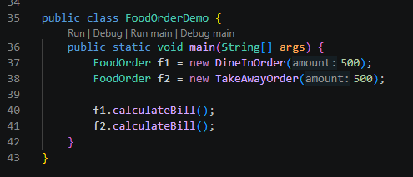
Output:
